INFO6023 – Game Algorithms & Gems – Mid-term
Friday, March 4th, 2017, 12:01 AM to 11:59 PM
Instructor: Michael Feeney

The exam format:
- The questions are not of equal weight. There are seven (7) pages with six (6) questions.

- The answers may be one or a combination of the following:

  - Short answer (in your own words)
  - Snippets of code
  - Complete running solutions
- CLEARLY indicate which answer goes to which question. My suggestion is that you place each answer in its own folder, named “Question_01”, “Question_02” and so on (or something equally clear). Another option is to create a Visual Studio solution and add a number of projects – one per question – to it.
- Place any written answers into a Word, RTF, or text file. Again, clearly indicate which question you are answering.
- If you are combining answers (which is possible), please indicate this with a “readme” file or some note (not buried in the source code somewhere) indicating this.
- For applications: If it doesn’t build and run; it’s like you didn’t answer it. I’ll correct trivial, obvious problems, but you need to be sure that it compiles and/or runs.
- This is an “open computer” style exam (like "open book" with the additional resources of what's on your computer, too) but keep in mind that you are supposed to be doing this exam completely on your own (with absolutely no communication or collaboration):
  - It is almost impossible that the basic structure of your code and/or the approach you take would be virtually identical to another student taking this test. This would indicate collaboration, in other words “plagiarism” or “cheating.”
  - I will be aggressively looking out for this kind of thing, as it is a clear violation of the college plagiarism policy.
  - Please refer to Policy 2-G-04 on Fanshawe Online or in the Student Handbook for more information.
- There may be a number of versions of the exam.

For all questions:

- You may only use the STL (Standard Template Library) to answer all questions, unless you are explicitly told otherwise (there is at least one question where you are allowed to use the STL but not certain part of it, for example).
- You may NOT use any threading libraries like boost, C11, (TBB) Threading Building Blocks, etc. The only “threading and synchronization” mechanisms allowed are the basic Win32 or C run-time calls (CreateThread, _beginthreadex, critical sections, etc.).
- Keeping in mind the plagiarism policy, you *can* use the code that was provided for you in class, you may not simply submit unchanged, or virtually unchanged, code we've done in class, even if it fully or partially answers the question. This goes the same for project code; you can’t just submit your project code, unchanged, and expect a mark for it (other than a mark of zero, that is).
- The idea of an “open book” (or “open computer”) test is not to simply find code that does what I’ve asked; the “open book” nature is so that you don’t have to memorize tedious details, like the parameter list of functions, etc.
- In other words: you should be able to do this test CLOSED BOOK. What I’m looking for is that you are capable of answering questions with no references whatsoever – but I also don’t think it’s fair (or sensible) to have to remember every single detail.

Save The Doctor from the Dalek invasion!

Doctor Who is trying to get away from the Daleks, who have landed on Earth. Unfortunately, his TARDIS is broken (what else is new?) and can only travel short distances at a time. Every time he appears, the Daleks in the area notice and come towards him.

Luckily for The Doctor, the Daleks can only travel on the roads. Yeah, yeah, I know that the Daleks can go over land and fly and whatever, but we'll assume they are Comicon type Daleks, than can only go over flat surfaces.

If you're not a Big Fan of Doctor Who, and don't know who the Dakeks are, here's a short video to check out: https://www.youtube.com/watch?v=5OnEhgGKgUs

Basically:
- Doctor Who is a "time lord", who lives in a time travelling ship called the TARDIS, that looks like a English "police box" (the story is the ship assumes some boring form, wherever it goes, but landed on Earth, took the form of the police box, then broke - or Doctor Who doesn't know how to work it properly), so still looks like that. It can move in time and space, sort of "teleporting" around. He's the "good guy".
- Daleks are bio-weapon aliens in some kind of battle armor, and move around like tanks. They look like some sort of robots, but apparently, they aren't robots (not that that really matters for this exam...).
- Daleks destroy anything that isn't a Dalek and actually destroyed Doctor Who's home planet. And they are super deadly, apparently. So, they are the "bad guys".
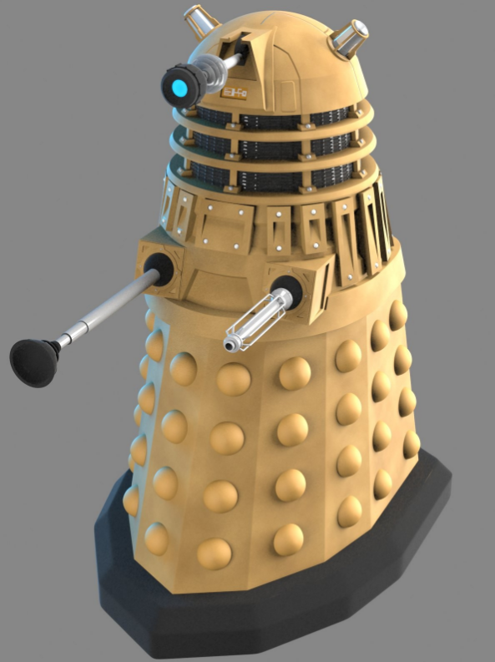
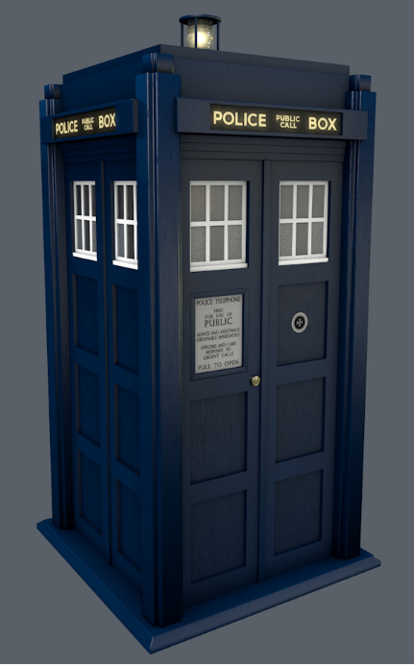

Doctor Who's TARDIS
A Dalek

- (20 marks) Create a city from the following 3D model components. There are four (4) types of interconnecting road pieces (corner, straight, T intersection, and X intersection), a number of different building pieces on a flat block (which are basically different sized blocks, with different textures, if you want to add the textures - which you don't have to do for this exam)
The street pieces are all aligned to the XZ axis (i.e. one corner is at 0,0,0 with one edge on the x axis, and one axis on the z axis) with their base aligned with the y-axis. The TARDIS and Dalek are aligned with their base on the x-z plane, centred on y.
Each road piece is the same sized square, and they all interconnect.
The city should be 5 x 5 "blocks" in size, where each "block" is 4 "straight pieces" long, so each "block" is basically this sort of arrangement:
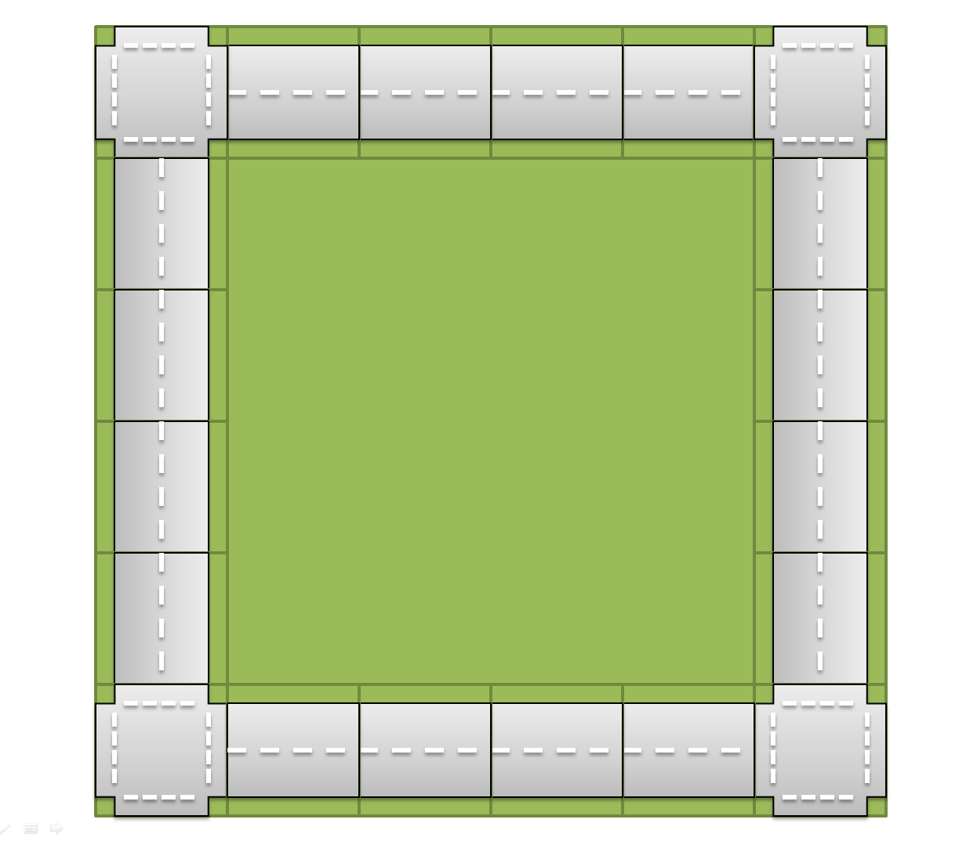

The centre green part is the large "flat" model.

There are four (4) "straight" road sections for each side, and four "corner" sections.
The whole "city" would look something like this:
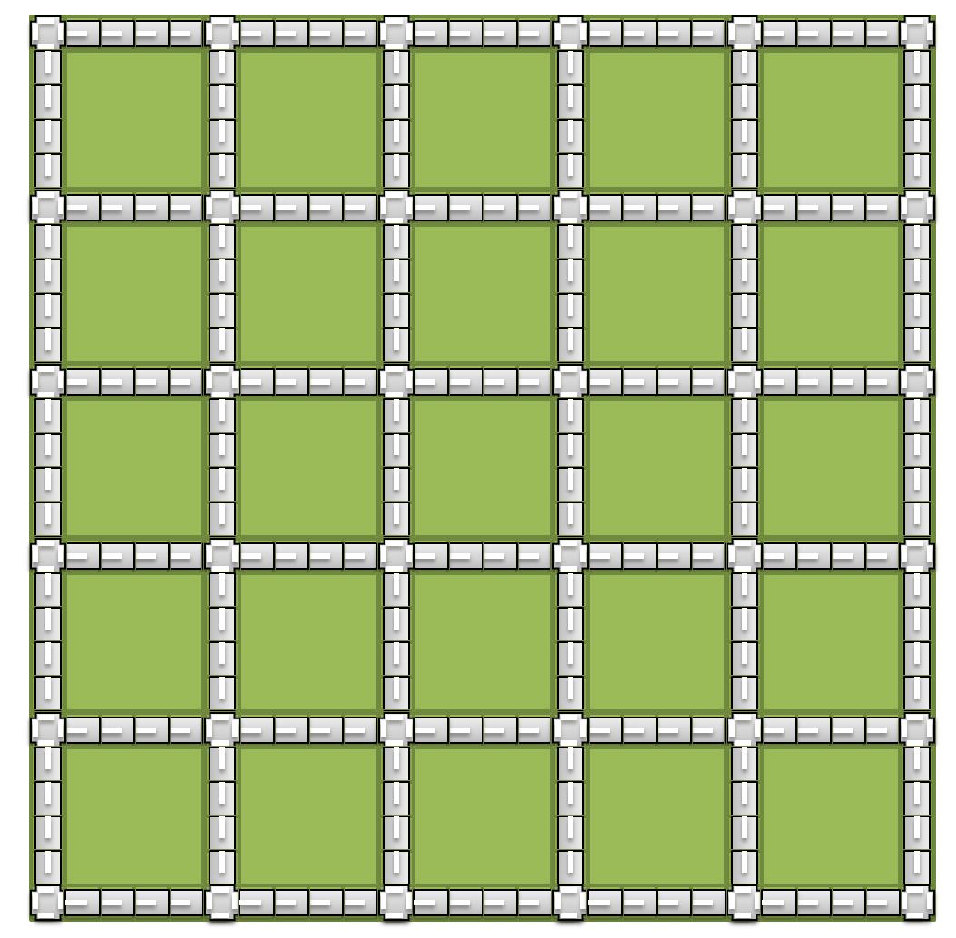
Note you can place the round "corner" pieces at the corners, and the "T" pieces around the streets along the sides, but keep in mind that you don't get any marks for this (though it does look nice).

Place random buildings in the "flat" portions.

- (20 marks) Place 500 Daleks in your scene, but only on the roads (i.e. avoiding the "building" areas). The Daleks should be approximately 1/50 in size of the road blocks (which are 100x100 units in size).
Note that there are three (3) different resolutions of Dalek model. You may use any type of model.
Using a single thread per Dalek, randomly move them around. Specifically, they should "choose" a direction to go in and a duration to move, from 1 to 5 seconds. At the end of that time, they pick a different direction and duration of movement. They should always be in motion.
You do not have to turn the Daleks model to face the direction of their movement.
Move them slowly around, staying only on the streets. Do not implement collision detection at this point - i.e. they can pass through each other.
Bonus (5-10 marks): point the Daleks in the direction of their motion. 5 marks for instantly pointing them, 10 marks if you take a moment to "turn" them before they move.
- (40 marks) NOW you implement collision detection.
Prevent the Daleks from inter-penetrating by having them be aware of each other and staying outside of a bounding circle (i.e. do not let them get within a certain small distance radius of each other).
If a Dakek "runs into" another, have it change direction and try again. This would happen during each simulation "step"; in other words, the Dalek chooses a direction and duration and attempts to move. If that step will move a Dalek "too close" to another Dalek, it will NOT move in this step (so will be stopped for this step).
The key here is that the Daleks are all running on their own thread, but must have access to the locations of all the other Daleks. This will be done by placing a common (shared) data structure of locations that all the Daleks can read and write from (they can real all the positions of all the Daleks, but only need to write their own locations). Implement whatever locking is needed to allow for quick multi-threading processing and prevention of instability (due to the multi-threading).
- (40 marks) Help the Doctor escape.
The Doctor needs to teleport his TARDIS from one corner of the map to the complete diagonal opposite corner. However, since his TARDIS is broken, he needs to do this in short jumps of at most, 100 units, or about the size of one of road pieces.
The TARDIS is also approximately 1/50th the size of the road pieces. This means that the TARDIS should teleport a maximum of about 50x the size of the TARDIS away.
In the main thread (i.e. the main function - you don't have to create a separate thread for this), choose a "safe" place to put the TARDIS within that 100 unit range from its current position.
This point is chosen in this manner:
  - The TARDIS will pick 1000 possible random points, within the 100 unit maximum range of its current position.
  - With each possible point, the distance to the closest Dalek is calculated.
  - At the end of these 1000 checks, pick the location that has the largest distance to any Dalek. If there is a tie, pick any of the best candidates.
  - The TARDIS can only teleport on roads (never in the "building" areas) or off the map entirely.
  - The location of the Daleks must be stored in a custom container of your choice (i.e. your own list, vector, map, queue, whatever container), not in an STL container. Note that you do not have to change the code from the previous questions; instead, you may copy the locations of the Daleks into your container before performing this "pick a new TARDIS location" process. However, if the previous questions were implemented entirely using your own custom containers, then this requirement is already met.
  - The TARDIS will stay at that new location until a Dalek gets within 5 units from it, then it will pick a new location.
  - When (if?) the TARDIS reaches within 50 unit of the opposite corner, The Doctor will escape, which you can indicate in some way. I’m not too concerned about exactly where this is, but approximately in the centre of the corner tile farthest from where you started.
  - The camera should move with the TARDIS in this manner:
    - It should always be "looking at" the TARDIS (which means when it teleports, it will "snap" to the new position)
    - It should "move" gradually towards a point up to 20 units from the TARDIS at a faster rate than any Dalek, but not at an "alarmingly" or "ridiculously" fast rate - something like a regular movie or game "follow camera" sort of shot. Think something like a camera attached to a remote controlled quad-copter drone (fast, but not too fast).

- (40 marks) Have the Daleks pursue the Doctor.

Alter the behaviour of any Daleks "near" the Doctor: If a Dalek is within 65 units of the TARDIS, instead of picking a random direction, then should simply move towards the TARDIS.
- (20 marks) There are three different resolutions of Dalek model. Implement a basic Level of Detail (LOD) procedure to include the medium and high resolution model of Daleks, and choose the appropriate model from its distance from the (moving) camera, with the highest resolution models being closest to the camera.
Use your discretion about which resolution you pick at what distance you transition between models. This will also depend on your machine and video card, of course. There should clearly be three different models at specific distances, though (even if this is not visually clear in your demo, it should be clear from your code that this is happening – or if I replace the models with three completely different models (a bunny for the high resolution, a teapot for the medium, and an airplane for the low resolution), it should clearly show that this distance based LOD is happening.

That’s it

